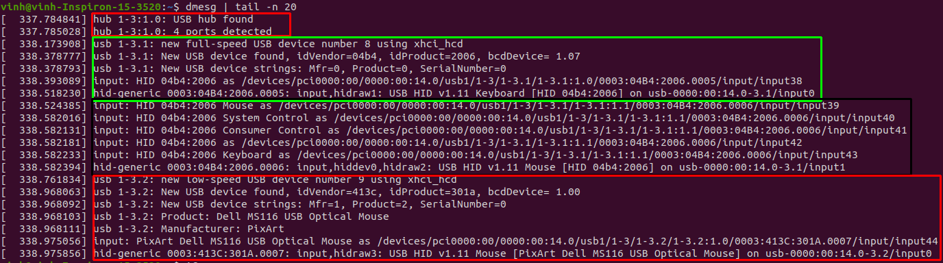
+ A hub has four ports
+ A keyboard → assigned to /dev/hidraw1
+
+ A mouse → assigned to /dev/hidraw3
=======================================================================
Mouse/keyboard → plugged in

+ 1. Kernel itself detects the new USB device:
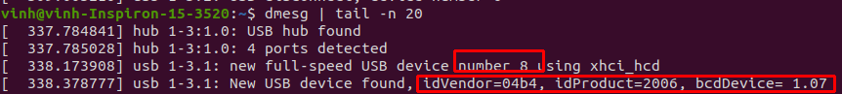
Assign the device number 8
Identify idVendor, idProduct, bcdDevice
+ 2. Kernel loads xhci_hcd.ko, usbhid.ko and hid-generic.ko to handle the device
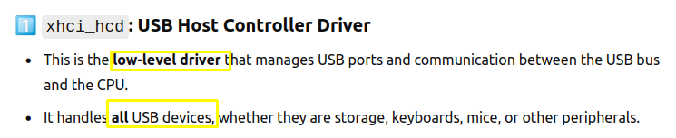
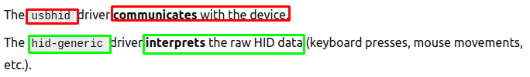

+ After, Kernel sends a uevent to ‘udev’, informing a new device is available:
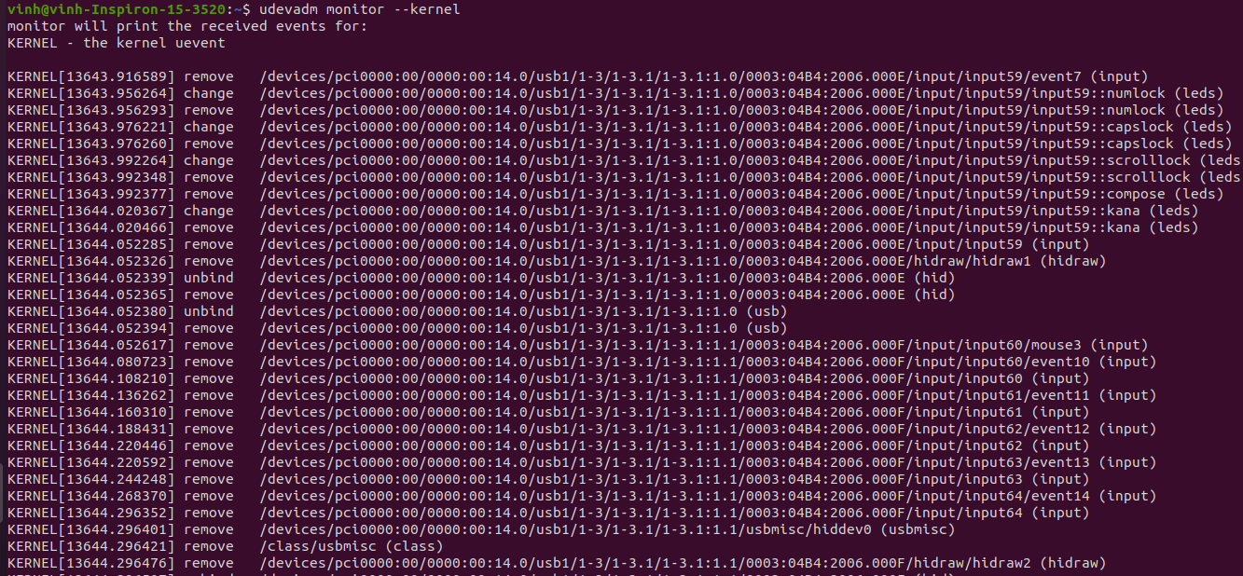

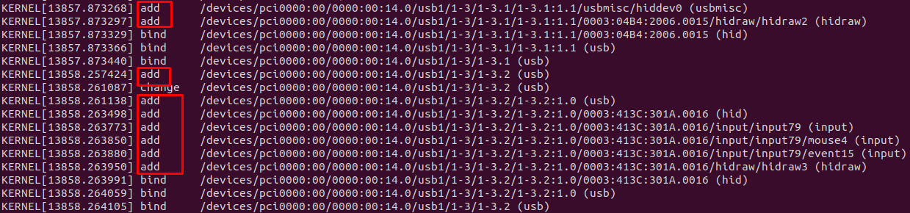
+ 3. Check against rules in /etc/udev/rules.d
+ 4. Create a device node in /dev/:
dev/input/eventX
dev/input/mouseX
dev/input/mice

dev/hidrawX

→ using command ‘evtest /dev/input/eventX’’

